In this Document，it will tell you how to preview RAW data and encode data from the HW device！

How to do the function？ You can refer to the EncodeDvrFCD.exe sample
To introduce the EncodeDvrFCD sample as follows：

1. Initial SDK and Board

The A and B API will be first called in executing the sample.
  - sdvr_sdk_init() :
Initial driver and resource. This function should be called only once
per session.

  - sdvr_get_board_count() :
Get the installed board count in this PC.

sdvr_set_av_frame_callback() :
Register callback routine for available video frames.
sdvr_set_video_alarm_callback():
Register callback routine for video analytic alarm.

  - You must click “Init All DvrBoard” in the pop-up menu.

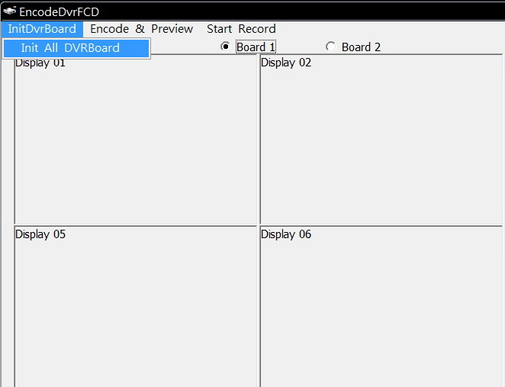

  - Select “*.rom” firmware file to upgrade.
sdvr_upgrade_firmware() :
Upgrade board firmware.
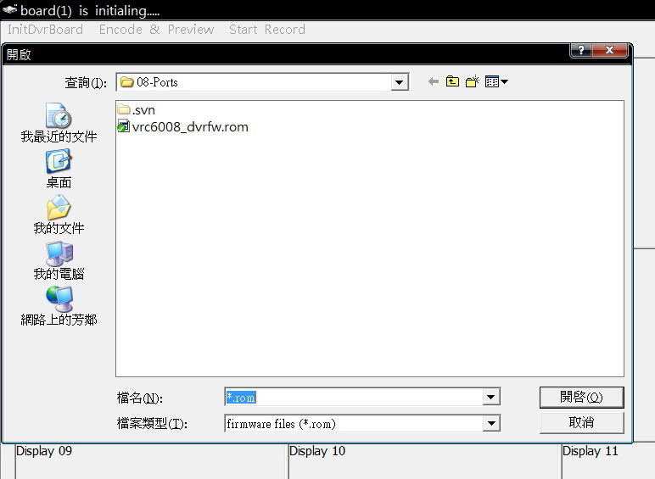

E. Get board’s config and status after upgrading the firmware.
sdvr_get_board_attributes() :
Get board’s supported video standards.
sdvr_get_sdk_params() :
Get SDK resource allocation parameters.
sdvr_get_pci_attrib() :
Get board’s PCIe attributes.
sdvr_get_board_config() :
Get installed board’s current configuration.

2. Encode and Preview
The HW device can preview the video(audio) raw data and encode the video(audio) raw data.
Note：
- The device can encode the video raw data to H.264, MPEG4 and MJPEG format.
- The sample shows the HW encode function

- First Click “Encode & Preview “ to select channel
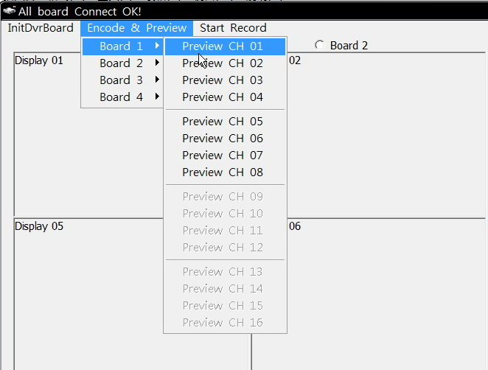

- Select the Encode format which you want

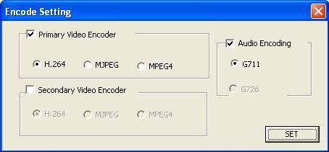

- Then, you will see the display video（RAW DATA）as follows：

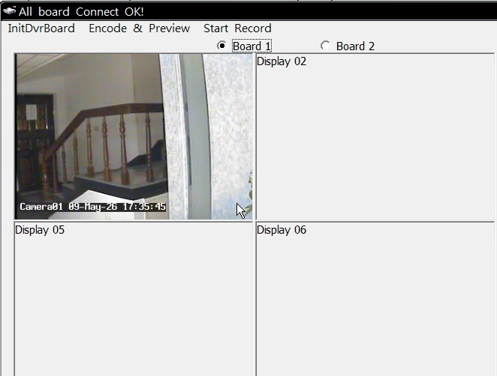

First create a encode channel
sdvr_create_chan():
Create an encode channel，but not start Recording
It is important that the encoding channel must be create before enable RAW
data or encode data

sdvr_stream_raw_video():
Enable or disable streaming raw video from board to host.
sdvr_stream_raw_audio():
Enable or disable streaming raw audio from board to host.

Click radio button “Board 1” ~ “Board 4” to switch encode board channel.

3. Start Record

A. Click “Start Record “ to set the encode setting

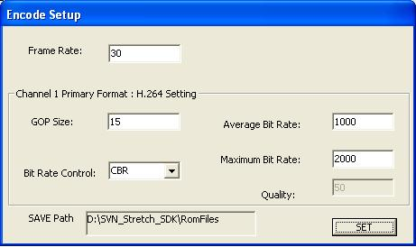

B. Sample will set the encoding channel’s encode video and audio data in
av_frame_callback function

sdvr_get_av_buffer:
Set a frame of encoded video or a packet Audio for a channel

sdvr_release_av_frame:
Release buffer resources for reuse

C. If you were encoding channel’s，you can double-click right button of mouse to set the
encode Setting

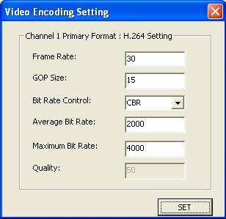

- Stop Encode and Stop Preview, Close Board and Close SDK

- Stop encode
sdvr_enable_encoder:
Disable the encoder for a channel

- Stop Preview
sdvr_stream_raw_video() :
Disable streaming raw video from board to host.
sdvr_stream_raw_audio() :
Disable streaming raw audio from board to host.

C. Destroy an encoding channel
sdvr_destroy_chan() :
Destroy an encoding channel
D. Close board. Click the “InitDvrBoard 01” menu to uncheck it.
sdvr_board_disconnect() :
Disconnect from board.

E. Close SDK.
sdvr_sdk_close() :
Close SDK. Must call this function before call sdvr_sdk_init() again

